Task 1:

This is my design for the assignment2 notification System. Since we need to notice all the driver when we need a delivery request. I would like to use to Observe Pattern as my project pattern.

I created the shop and driver as independent class, so that I can add as many taxiDriver and shop as I want. When I have new driver, I can use the method add driver to add it to our notification System, then he also can receive our notification.

When I have a now shop, just create a new shop object, and use the needDeliveryRequest() method which builtin the notification System, and use the shop object as the param, to send the notification to all the driver object.

NotificationSystem also is an independent class, so that I can make a lot of different notification System, this can be easy to manage different kind of notification system for different specific area.

Task 2:

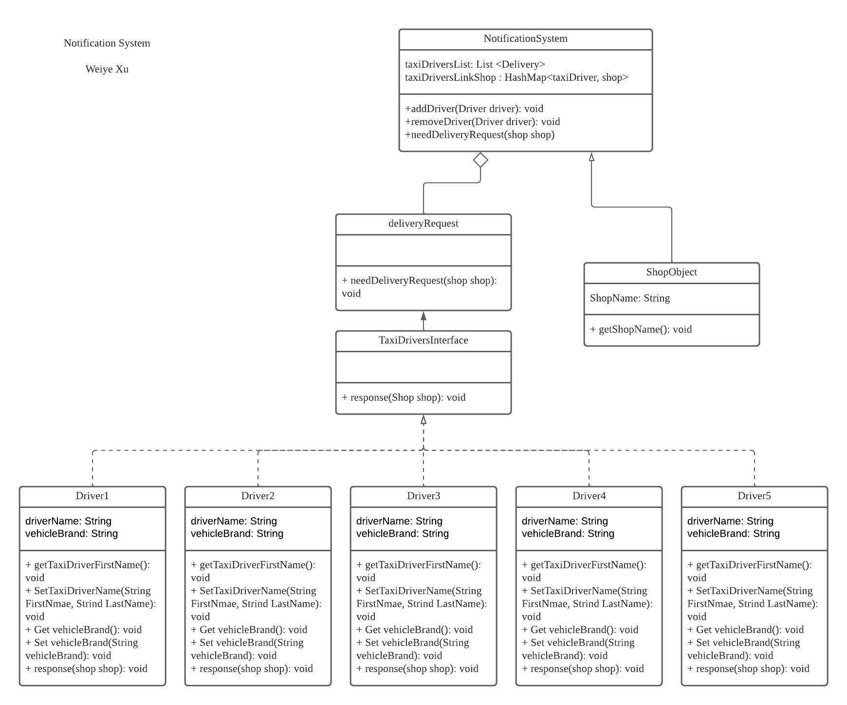

Task 3:

